**Evaluating effect size distribution of different regenerative agriculture practices across soil, climatic and topographical factors**

**Ozias Hounkpatin, Johannes Piipponen, Mika Jalava, Matti Kummu**

**Abstract**

Soil conservation practices (SCPs) related to regenerative agriculture are increasingly promoted for enhancing ecosystem services while supporting sustainable crop production. However, their effects on yield remain context-dependent and inconsistently reported. Here, we conduct a global meta-analysis of 10,002 paired observations from 732 studies, evaluating yield changes across four RAPs—agroforestry (AF), cover cropping (CC), no-tillage (NT), and organic farming (OF)—relative to conventional tillage. Integrating environmental moderators, including climate, topography, and detailed soil properties, we assess effect size distributions across spatial and agronomic gradients. Results indicate that, overall, RAPs increased crop yields by a modest 0.7%, with AF and CC showing the highest gains (12% and 7.5%, respectively), while NT and OF showed slight yield declines (−0.7% and −2%). Yield benefits were more pronounced in arid and temperate climates, low fertility soils, and elevated terrains. Crop-specific responses varied, with maize and cash crops benefiting most. Management combinations under NT influenced outcomes significantly, with nutrient input and soil cover proving essential in arid environments. These findings underscore the need for site-specific, integrated implementation of (SCPs) and highlight their potential to enhance productivity in degraded or climatically constrained regions.

1. **Introduction**

More than 70% of the Earth’s land area which was initially covered by forests and wildlands have been transformed to various use by human being1. A large fraction of such use is devoted to agriculture occupying about 40% of the world land area. However, food production results in a huge environmental footprint with one-third of soils in the world being degraded and fertile soil being lost at the rate of 24 billion tons of topsoil every year2 along with about 34% of global greenhouse gas emissions3. Meanwhile, it is projected that food production would have to increase in the future to satisfy both the need of the global growing population and the increase in per capita demand4. In this context, sustainable pathways that would contribute to land restoration, biodiversity protection and GHG mitigation are more and more emphasized.

Regenerative agriculture has emerged as an alternative farming strategy seeking to achieve global food security by reducing the use of external inputs, improving soil health and minimize environmental damage5-7. It involves different soil conservation practices (SCPs) such as reduced or not tillage (NT), cover crop (CC), perennials and agroforestry (AF), organic farming (OF) as well as crop-livestock integration6,8. Previous studies reported potential beneﬁts of different SCPs for increasing soil organic carbon (SOC) and soil water uptake as well as GHG mitigation climate mitigation 6,8,9. Thus, although environmental benefits seem to be considerable, yield outcomes through the implementation of different SCPs are subject to many controverses.

Some existing studies have shown that SCPs could potentially result in increasing yields10,11 while others reported a neutral or declining trends12,13 after implementation. While evaluating the outcome of different crops and environmental variables on NT as compared to conventional tillage (CT) yields, Pittelkow, et al. 14 show that NT impact on yield is dependent upon the region with increasing trend in moisture-limited arid regions while declining patterns are observed in tropical regions with maize-based systems. A global meta-analysis based on740 paired measurements from 90 peer-reviewed articles show that NT increased barley yield by 49% especially in dry climate15. In a drought period, about 60% higher maize yields were observed under NT management compared to CT16. However, contrary trends are also reported with the application of crop rotation, residue management, and no-tillage having no effect on yield stability relative to CT17. The same study showed that OF had 15% lower yield compared to CT.

Under AF management, findings show that yield either increased by 7 – 16% in crop yield especially in subtropical and tropical zones18, or reduced by 2.6% in European areas depending on the density and age of the trees19. While about 14% yield increase is reported under CC especially in coarse soil texture and dryland areas along with the use of leguminous cover crops20, about 3% yield reductions were observed especially for cash crops in temperate soils21,22. About 10% decrease in wheat yields were observed following cover cropping23. In context whereby there is no significant increase or decrease, some studies reported that yields could be sustained for longtime under SCPs especially for degraded soils24.

The discrepancy of yield outcomes under different SCPs have thus shown that various factors interplay to determine the magnitude and direction of crop yields for farmers. However, there is a need of having a better understanding on how environmental factors affect crop yield changes under different SCPs. Though previous meta-analysis studies have analyzed the variation in productivity across different management practices, they mostly focus on a single type of SCPs11,25-27 without investigating their comparative potential across various factors and crop types at a global scale. To our knowledge, these studies do not include or have incomplete records of key soil variables such as bulk density, soil organic carbon, phosphorus, pH, texture, cation exchange capacity, or topographic variables such as elevation and slope or climate variable such as temperature, precipitation, crop growing degree days etc.

Consequently, these studies do not involve a large range of environmental factors except for some NT studies which considered alongside management variables such as soil texture 11,28 or aridity25 as well as climate zones or climatic variables such as temperature and precipitation. However, advances in remote sensing technology in recent decades have resulted in the existence of global earth data with the affordability and accessibility of satellite imagery which provide valuable information on environmental conditions and variables related to soil properties (e.g. soilGrids), climate, topography etc. which in turn are potential factors affecting crop yields29-31. Our current study is unique in that it focuses on different SCPs and their influence on relative crop yields across climatic, topographic variables and additional soil properties beyond texture. Therefore, the objective of this paper is to take an advantage of global earth and field experiment data to assess the distribution of SCPs related relative yields among different conditions defined by environmental factors at a global scale. A profound understanding of the

variability of SCPs related yields across different influential factors should facilitate deeper insight into selecting appropriate SCPs in different regions and thereby support targeted planning for sustainable development.

1. **Materials and methods**
   1. **Data collection**

Different global meta-analysis data from Xu et al.11, Jian et al.32, Pittelkow et al.25, Xia et al.33, Verret et al.34, Ding et al.35 and Felix et al.26 were combined in the present study. This resulted in a total of 10 232 comparisons between SCPs and CT (i.e. conventional tillage), from 758 publications covering 773 sites worldwide (Figure 1). After compiling the data, the crop types were classified into seven groups with the most cultivated crops in the world such as maize, wheat, soybean and rice considered separately. The remaining crops were categorized cereal, cash-crop and vegetable & fruits and others (see Table 1 in supplementary material). The compiled data cover the following SCPs practices: Agroforestry, Cover Crop, No-tillage, organic

farming.

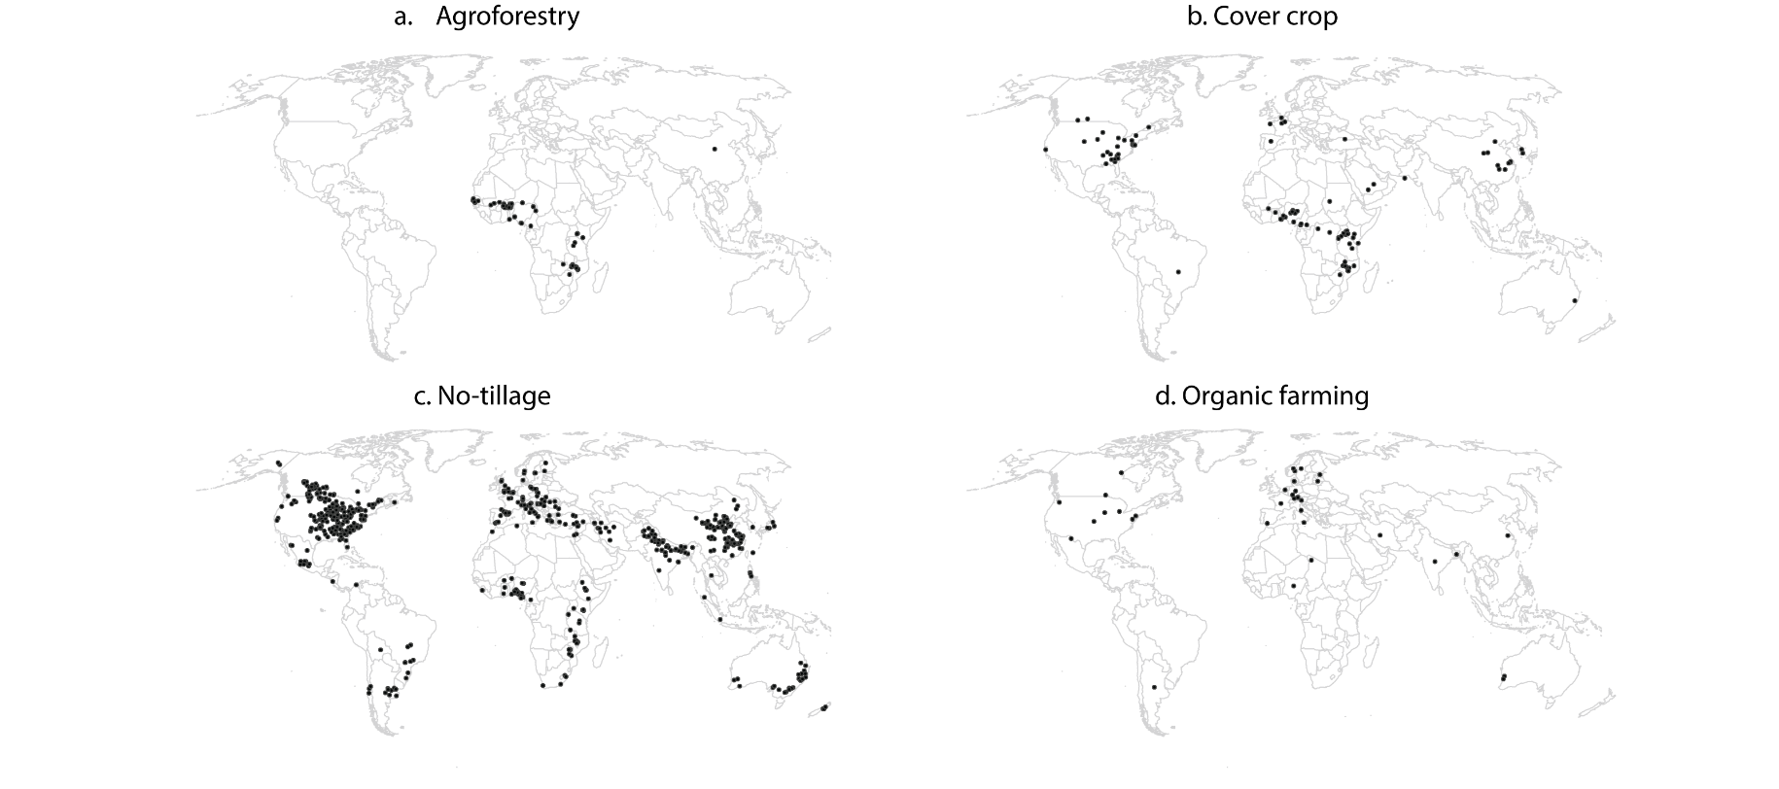Figure 1: Global distribution of the study sites

* 1. **Environmental and management effect size moderators**

The impact of the SCPs on crop yields was assessed based on three environmental components: climate, soil properties and terrain. For each of the three components, several indicators were identiﬁed (Table 1).

Climate, soil properties and terrain variables have been documented to have a major impact on crop growth and food production36-39. As climate variables, precipitation and temperature are closely associated with crop growth and crop yield and affect soil moisture status which in turn determines whether water might be a limiting factor the crop phenological development. The aridity considered in this study as climate indicator is defined as the ratio of precipitation to potential evapotranspiration and

is a measure of moisture availability for crop growth. The global aridity index for the 1970–2000 period was obtained from the Consortium for Spatial Information (1 km)40. The Growing Degree (GDD) measures the heat accumulation over the growing season and is a measure of the relationship between temperature and plant development. The Growing degree days (GDD) used in this based was sourced from Ahvo, et al. 41.

Terrain attributes interact with weather to affect soil temperature and moisture42,43. Water stress occurs most likely in upslope positions with lower and higher variability in yields compared to lower slope positions44-46. Terrain indicators such as elevation and slope (1 km) were obtained via the platform provided by the global study of Amatulli, et al. 47. The landform grid data was sourced from the study of Iwahashi and Yamazaki 48.

Soil properties determine the local environment for crop growth by affecting soil aeration, nutrient cycling and root growth49,50. For instance, soil texture affects the available water capacity in the root space while soil pH influences the availability of nutrients to plants and microbial activity51,52. Global soil properties such as soil texture (sand, silt, clay), bulk density (BD), soil organic carbon (SOC), pH, soil types were downloaded from the SoilGrids (250 m) platform which is a global soil information system developed by ISRIC – World Soil Information 53. The global stock of soil Olsen phosphorus came from the global study carried out by McDowell et al.54

In addition, additional management variables such as cover crop (yes/no), N fertilizer (yes/no), weeding (yes/no) and rotation (yes/no) were considered for NT. Consequently, under each component, the distribution of the ES under NT was further analyzed for each of these management variables.

* 1. **Data analysis**

The data analysis focused on the effect size (ES), i.e. the response ratios (RR) of crop yield to these management systems and was assessed by taking the natural logarithm calculated of RR following Luo, et al. 55 : RR = ln(XT/XC) where XT and XC are the yield value under treatment (NT, AG, CC, or OF) and control, respectively. Moderator analysis was conducted to determine the SCPs effects ES. This analysis was carried out by grouping the metadata into the following categories:

* Crop groups: The previously defined crop groups were considered: maize, wheat, soybean and rice, cereal, cash-crop and vegetable & fruits and others.
* Bulk densities: Low values of BD describe permeable soils allowing plant to reach the nutrient and water easily while high values denote a compacted soil with high mechanical impedance resulting in limited roots growth. It was categorized into three different categories: low (< 1.2 kg/dm3) , moderate (1.2 kg/dm3 < BD < 1.47 kg/dm3), high (BD > 1.47 kg/dm3)56.
* pH: Three categories were considered: acidic soils (pH < 6.3,) neutral soils (6.3 < pH < 7.4) and alkaline soils (pH > 7.4).
* Phosphorus: The P distribution classes were low: P < 10.9 mg/kg, moderate: 10.9 mg/kg < P < 21.4 mg/kg and High : P > 21.4 mg/kg57.
* Soil organic carbon: Three categories were considered: SOC < 5 g/kg, 5 g/kg < SOC < 10 g/kg and SOC > 10 g/kg58.
* Soil texture: soil textures were classified into three broad categories: fine (clay, silty clay loam, clay loam, and sandy clay), medium (silt loam and loam), and coarse (sandy loam and sand), following USDA Soil Taxonomy59 and FAO guidelines60.
* Soil types: Classes of soil types were used as defined on SoilGrid platform (see Table 2 in supplementary material).
* Aridity: It was divided into five categories: Hyper-Arid (AI < 0.05), arid (0.05 < AI < 0.2), semi-arid (0.2 < AI < 0.5), sub-humid (0.5 < AI < 0.65) and humid (AI > 0.65)40.
* Growing degree days: Four classes were considered: unsuitable (GDD < 800°C/y), suitable (800°C/y < GDD < 2700°C/y), heat Stress (2700°C/y < GDD < 6000°C/y), high heat Stress (4000°C/y < GDD < 6000°C/y)61,62.
* Elevation: The following elevation classes were considered: < 250 m, 250 – 1000 m and > 1000 m.
* Slope: Five slope classes were defined60: < 0.20%, 0.2-1%, 1-5%, 5-15%, and > 15%.
* Landform: The initial 22 landform classes were reduced to 15 by grouping similar contour line classes (see Table 3 in supplementary material).

Using bootstrapping with 1000 resamples of the mean response ratio, 95% confidence intervals were estimated for each category. An effect size was considered non-significant if its confidence interval included zero.

Table 1: Environmental variables (in bracket are abbreviations)

|  |  |  |  |
| --- | --- | --- | --- |
| Component | Indicators | Unit | Resolution |
| Soil properties | Soil texture | % | 250 m |
| pH |  | 250 m |
| soil organic carbon (SOC) | g/kg | 250 m |
| Soil Olsen phosphorus concentrations (phosphorus) | mg/kg | 1000 m |
| Bulk density (bd) | kg/dm³ | 250 m |
|  | Soil type |  | 250 m |
| Terrain | Slope | % | 0.0083° |
| Digital elevation model (dem) | m | 0.0083° |
|  | Geormorphological landform |  | 0.0083° |
| Climate | Growing degree days for maize (GDD_maize) | ° C | 0.0083° |
| Growing degree days for wheat (GDD_maize) | ° C | 0.0083° |
| Growing degree days for rice (GDD_maize) | ° C | 0.0083° |
| Growing degree days for soybean (GDD_maize) | ° C | 0.0083° |
| Aridity index (aridity) |  | 0.0083° |

* 1. **Publication bias and sensitivity analysis**

# The consideration of the variance for each study is usually required in meta-analysis for conducting using a funnel plot analysis. However, the majority of the studies did not provide the variance for such purpose. Therefore, the density plots of the different SCPs were created to check the distribution of all individual effect sizes in the dataset to check potential publication bias 63,64. Moreover, a sensitivity analysis was carried out using the Jacknife approach to determine the robustness of the analysis65. Every study was given a distinct study ID during the Jacknife analysis process, and data from one study was removed from the database for every computation.

1. **Results**
   1. **Analysis of the entire data set across regenerative agriculture practices, crops and environmental variables**

# Across the entire dataset, sustainable cropping practices (SCPs) resulted in a modest overall yield increase of 0.7% (Fig. 2). However, responses varied markedly by practice and crop. Agroforestry (AF) and cover cropping (CC) significantly enhanced yields, increasing them by 12% and 7.5%. In contrast, no-till (NT) and organic farming (OF) were associated with yield reductions of 0.7% and 2%. Among crops, significant yield gains were observed only in maize and cash crops, which increased by 1.7% and 0.7% respectively.

# Across climate types, arid regions showed the greatest yield increase, averaging 3.8%, followed by a 1.8% rise in temperate regions (Fig. 2). This pattern was supported by the aridity index, with mean yield increases of 9% and 2.7% observed in arid (0.05–0.20) and semi-arid (0.20–0.50) zones. In contrast, continental regions experienced a yield decline, while tropical areas showed no significant change.

# Significant yield changes across growing degree day (GDD) ranges varied by crop. Maize showed notable increases at 2700–4000 GDD (1.9%) and 4000–6000 GDD (5.7%). Rice exhibited high yield gains below 800 GDD (11.6%) and between 4000–6000 and 6000–10000 GDD (2.8% and 2.7%). Soybean yields increased most within 2700–4000 and 4000–6000 GDD ranges (1.9% and 5.7%), while wheat showed its largest gains at 800–2700 GDD (1.8%) and 6000–10000 GDD (3.8%).

# Regarding soil properties, the greatest yield increases were observed in crops grown on low soil organic carbon (SOC) soils (10%), coarse-textured soils (1.76%), and both alkaline (1.38%) and acidic soils (1.24%). Significant gains also occurred in soils with phosphorus levels below 10.9 mg/kg (1.3%) and between 10.9–21.4 mg/kg (0.5%), as well as in soils with low (<1.20 kg/dm³, 1.05%) or medium bulk density (1.20–1.47 kg/dm³, 1.3%). Conversely, crops grown on neutral soils experienced significant yield declines. Based on soil classification, the most substantial yield increases occurred in Lixisols (18.3%), Arenosols (14.6%), Calcisols (12.7%), Regosols (4.6%), Acrisols (3.7%), Luvisols (2.3%), and Kastanozems (2.9%). In contrast, significant yield reductions were recorded in Alisols (17.5%), Gleysols (11.3%), and Phaeozems (4.3%).

# Significant yield increases were observed at elevations exceeding 250 meters. The distribution of effect sizes (ES) across slope gradients revealed positive yield responses, with the most notable occurring on gentle slopes (1–5%) with a mean yield gain of 3.4%, and on strong slopes (15–30%) with a mean gain of 11%. Gently sloping areas (5–15%) also showed a positive effect, with a mean increase of 0.53%. Yield increases were generally positive across landforms, except in high plains (Hi_plain), valley slope (Val_sl), moderate hills (Mod_hills) —areas typically found at lower elevations. Conversely, the most pronounced yield gains occurred in high-elevation landforms, ranging from mountain valley slope (Mtn_vs) to the mountain summit (Mtn_sumt).

# 

Figure 2: Distribution of the percentage change of the effect size between regenerative agriculture practices, crop groups, soil properties, terrain, and climatic variables (SCPs: Regenerative agriculture practices, V_F_others: Vegetable, fruits and others, P: Phosphorus, BD: bulk density, GDD: growing degree days, Mtn_sumt: Mountain summit, Cliff_sl: Cliff slope, Lwhi_mtn: Lower/hilly mountain, Shills_dcsl: Steep hills / dissected cliff slope, Lhgsl_steep: Large highland slope steep, Lhgsl_mod: Large highland slope moderate, Mtn_vs: Mountain valley slope, Mod_hills: Moderate hills, Tfphi_dis:Terrace/fan/plateau (high, dissected), Tfphi_surf: Terrace/fan/plateau (high, surface), Val_sl: Valley slope, Tfplw_dis: Terrace/fan/plateau (low, dissected), Tfplw_surf: Terrace/fan/plateau (low, surface), Hi_plain: High plain (Sinks < 50%), Lw_plain: Low plain (Sinks < 50%). Effect size (ES) represents the yield change in relation to control in experiment; positive effect size means treatment in experiment resulted in higher yield compared to control, negative effect size means treatment in experiment resulted in lower yield compared to control. The symbols used in the figure include dots with error bars, representing the overall mean effect size values ±95% confidence intervals. Categories whose 95% confidence intervals do not include 0 (represented by the vertical red lines) have significant differences between regenerative agriculture practices and controls

* 1. **Effect size distribution across climate variables for different soil conservation practices**

The trend across specific SCPs (Fig. 4) showed that AF recorded a higher yield increase (12%) than CC (7%), NT (-0.7%) and AF (-2%). Cropwise, while most crops have positive mean yield grain under CC the results were mixed for the remaining. Significant yield increase occurred mainly with maize under AF, CC and OF. Similar trend was observed for cash crop under CC and NT. For arid (ariditity index: 0.05 – 0.20) and semi-arid (ariditity index: 0.20 – 0.50) regions, significant yield increases were observed under AF and NT. Interestingly, most of the positive yield gain obtained under OF occurred also in the semi-arid regions with the 0.20-0.50 aridity index range. AF recorded its highest yield gain in temperate regions (36%). While for more humid areas, a higher yield increase trend is observed for AF and CC especially with aridity index above 0.50.

Generally, high GDD (> 4000°C) resulted in higher yield increase with maize under AF and CC. Meanwhile, significant increase at lower GDD (< 800°C) was only recorded for maize under OF and for rice under NT and OF. For both rice and soybean, there appeared to be higher yield increase above 4000°C under CC. For GDD between 800 and 2700°C, wheat recorded a significant yield increase under CC and OF while above 6000°C GDD, similar tend only occurred with CC. Interestingly, most yield increase for maize, rice and soybean at very low GDD (<800°C) occurred under organic farming.

Across the soil properties, yield increase generally occurred with decreasing bulk density especially under AF, CC and OF. Increasing P resulted also generally in increasing yield except for larger P (> 21.4 kg/mg) content which translated into negative impact under CC, NT and OF. All SCPs present high yield increase in soils with low SOC (< 5 g/kg) except OF. However, for soils with higher SOC (> 5 g/kg), AF and CC still recorded high yield increase but in lower magnitude compared to soil with low SOC. Coarse texture soil recorded positive increase across all SCPs except OF but the significant yield records were only found with CC (9%) and NT (3%).

# Considering elevation, significant yield increase was observed for high plain areas above 250 m for both AF and CC. This is further confirmed for these two SCPs by the distribution of the effect size across the different landform with generally positive yield increase from the mountain summit to the moderate hill. OF also recorded similar trend in areas characterized by large highland slope moderate (Lhgsl_mod). In addition, CC and NT recorded a significant yield increase for landforms occurring mostly at lower elevations especially for areas on dissected terrace/fan/plateau (Tfphi_dis) and valley slope (Val_sl) for NT on the one hand and for dissected terrace/fan/plateau (Tfphi_dis), low surface Terrace/fan/plateau (Tfplw_surf) and high plain (Hi_plain) areas for CC on the other hand. For slope, it appeared that most significant yield increase are recorded for AF on level to gently sloping areas (slope: < 15%) while on gentle (1-5%) or strong slopes for CC (< 15%).

The performance of the SCPs varies across different soil types. For AF, significant yield increase and decrease occurred with Acrisols and kastanozems respectively. The most significant yield increase records were with Cambisols, Luvisols and Vertisols under CC and with Alisols, Fluvisols, Phaeozems under NT. With Calcisols, Gypsisols, Histosols, Luvisols NT recorded a significant yield decrease. OF recorded a high yield increase with Ferranosols and Phaeozems, although not significant with the latter.

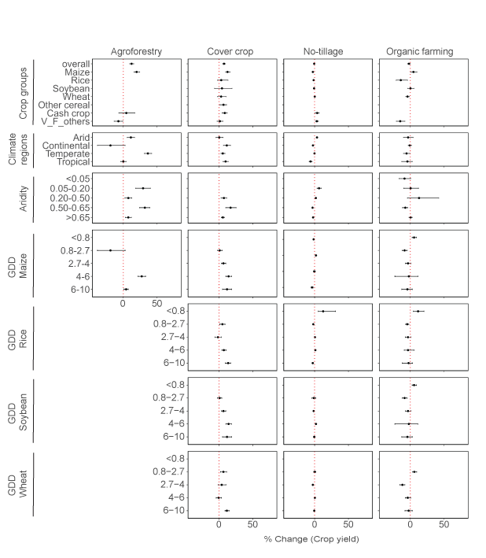Figure 3: Distribution of effect size across crop groups and climatic variables for different regenerative agriculture practices. The symbols used in the figure include dots with error bars, representing the overall mean effect size values ±95% confidence intervals. Categories whose 95% confidence intervals do not include 0 (represented by the vertical red lines) have significant differences between regenerative agriculture practices and controls. V_F_others: Vegetable, fruits and others, GDD: growing degree days.

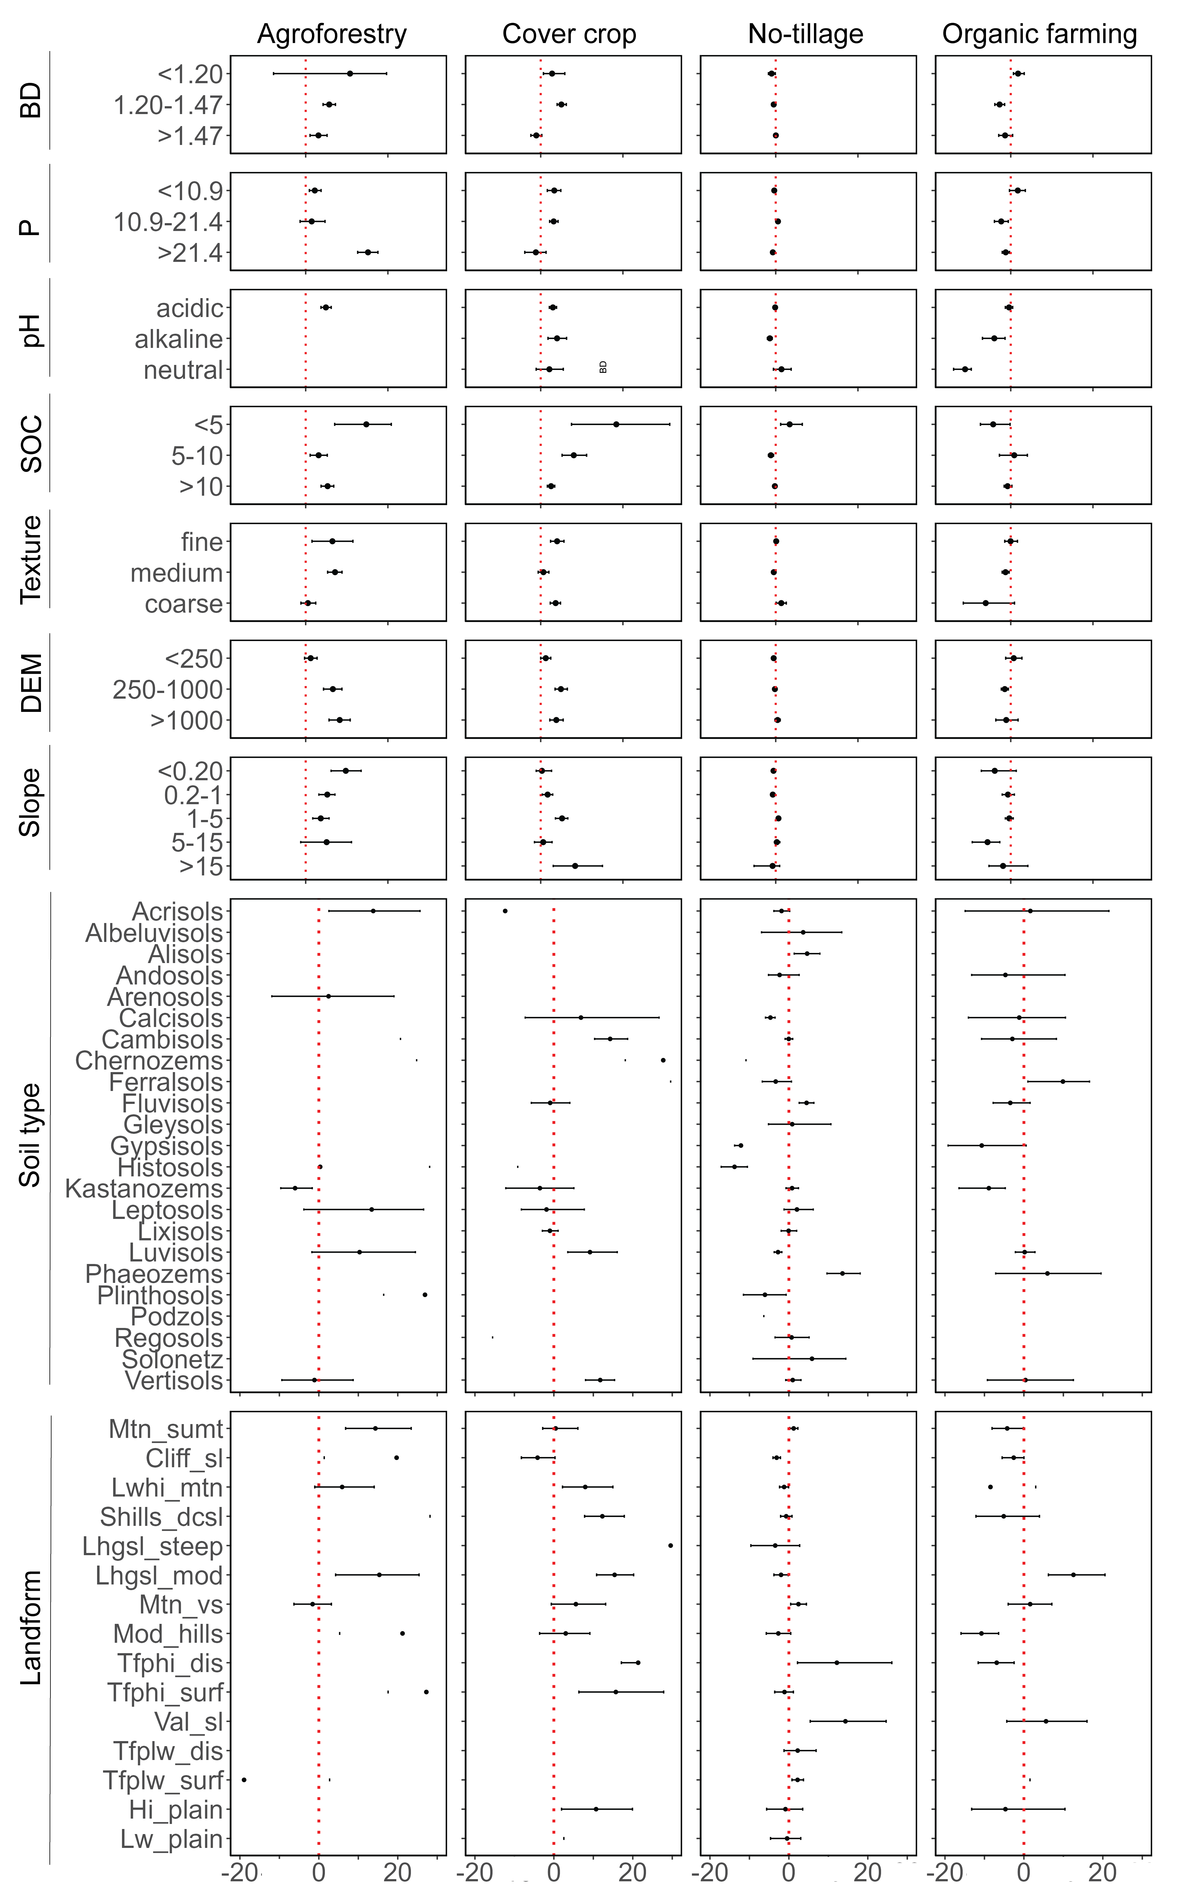

Figure 4: Distribution of effect size across soil properties and terrain for different between regenerative agriculture practices. P: Phosphorus, BD: bulk density, DEM: digital elevation model**.** , Mtn_sumt: Mountain summit, Cliff_sl: Cliff slope, Lwhi_mtn: Lower/hilly mountain, Shills_dcsl: Steep hills / dissected cliff slope, Lhgsl_steep: Large highland slope steep, Lhgsl_mod: Large highland slope moderate, Mtn_vs: Mountain valley slope, Mod_hills: Moderate hills, Tfphi_dis:Terrace/fan/plateau (high, dissected), Tfphi_surf: Terrace/fan/plateau (high, surface), Val_sl: Valley slope, Tfplw_dis: Terrace/fan/plateau (low, dissected), Tfplw_surf: Terrace/fan/plateau (low, surface), Hi_plain: High plain (Sinks < 50%), Lw_plain: Low plain (Sinks < 50%). Effect size (ES) represents the yield change in relation to control in experiment; positive effect size means treatment in experiment resulted in higher yield compared to control, negative effect size means treatment in experiment resulted in lower yield compared to control. The symbols used in the figure include dots with error bars, representing the overall mean effect size values ±95% confidence intervals. Categories whose 95% confidence intervals do not include 0 (represented by the vertical red lines) have significant differences between regenerative agriculture practices and controls.

* 1. **Effect size distribution across different no-tillage management practices**

The effect of no-till (NT) on yield varied across climatic regions and management practices (Fig. 5). Overall, NT implementation led to significant yield increases of 14.7% and 9.8% in arid and temperate regions, respectively, while yield declined in continental (–0.1%) and tropical (–8.7%) regions. The greatest positive impacts of NT were observed in arid zones, particularly under management regimes combining nitrogen input, soil cover, and weed control—with or without crop rotation—yielding increases up to 39%. Other effective combinations in arid regions included nitrogen input with soil cover and weed control (20%), nitrogen input with soil cover alone (1.2%), and nitrogen input with weed control (4.8%). In temperate regions, positive yield gains were noted with nitrogen input combined with soil cover, weed control, and rotation (2.6%), as well as soil cover with weed control (2.5%). The largest increases occurred under management including nitrogen input with soil cover and weed control (20%) as well as nitrogen input plus soil cover (8.3%).

In continental regions, NT resulted in positive yield responses under select management combinations, with increases of 0.09% for nitrogen input with soil cover and weed control, and 6.1% for soil cover with weed control. The greatest gain, 20%, was observed when rotation was added to soil cover and weed control. Conversely, in tropical regions, most NT management strategies resulted in significant yield declines, except for the combination of nitrogen input, soil cover, and weed control, which produced a slight increase of 1.1%.

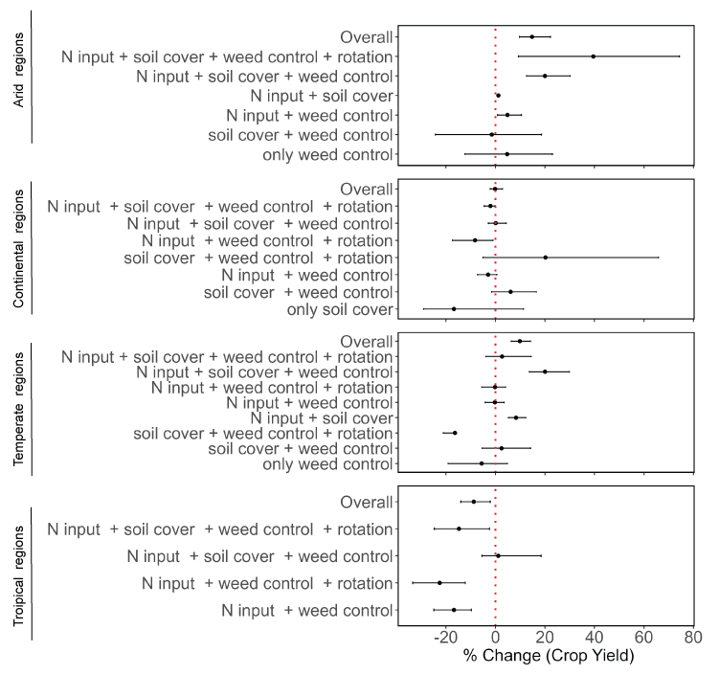

# Figure 5: Distribution of effect size across different no-tillage management practices. N: nitrogen. In bracket are the number of observations per management.

* 1. **Publication bias and sensitivity analysis**

The density distribution plot and the histogram showed that the observations related to the different SCPS were close to the normal distribution (Fig. 6a,b), suggesting that the meta-analysis was not subject to publication bias. Although a small number of studies produced estimates fell outside the 95% confidence interval when removed, the results of the Jackknife sensitivity indicated that the exclusion of individual studies did not substantially alter the pooled effect, as most of the resulting estimates remained within the original 95% confidence interval (Fig. 6c).

# 

# **Figure 6:** The (a) density plot (b) the sensitivity analysis for each regenerative agriculture practice. The lower and higher 95% confidence intervals are provided as dashed red lines. AF: Agroforestry, CC: cover crop, NT: no-tillage, OF: organic farming.

1. **Discussion**

The large-scale implementation of conservation and soil protection practices (CSPs) necessitates a comprehensive understanding of the underlying processes and mechanisms influencing crop yield across diverse environmental contexts. While previous studies have documented variable outcomes—including yield increases, decreases, or no significant change—many have not adequately explored the fundamental biophysical and management factors driving these yield responses 10,12,13. However, such knowledge is crucial for context-specific implementation of such practices. This study provides a comprehensive assessment of the impacts of different soil conservation practices on crop yield, considering a broad range of crop groups, climate regimes, soil properties, and terrain characteristics.

The overall finding that SCPs associated with regenerative agriculture led to small but significant increases in crop yield, with a pooled average increase of 0.7%, supports growing evidence that sustainable intensification is achievable through nature-based solutions. However, the magnitude and direction of yield responses varied considerably depending on the specific practice, crop type, and environmental context created by the interplay of climate regimes, soil properties, and terrain characteristics.

* 1. **Crop yield change across practices**

Among the practices evaluated, agroforestry (AF) and cover cropping (CC) demonstrated the most consistent positive impacts on yield, with mean increases of 12% and 7.5%, respectively. While these findings align with previous research highlighting the beneficial effects of diversified cropping systems, the magnitude of the effect differs across studies10,20,66. For example, Ren, et al. 10 recorded increased crop yield by 11% and 66% for CC and AF respectively. On the other hand, our finding for CC is substantially higher than the global mean increase of 2.6% reported by Peng, et al. 20 and slightly lower than the 9.2% increase observed in cases where leguminous cover crops were used. These differences are possibly due to differences in soil conditions, climate, and management practices. In contrast, no-tillage (NT) and organic farming (OF) were associated with modest yield declines (−0.7% and −2%, respectively), which may reflect challenges related to nutrient availability, weed pressure, or delayed adaptation of these systems in certain contexts25,67,68.

* 1. **Crop yield change across specific crops and growing degree days**

Crop-specific responses also varied. Maize and cash crops showed significant yield gains, while other crop types exhibited mixed responses. These findings suggest that certain crops may benefit more from SCPs, potentially due to their physiological traits, input requirements, or interactions with improved soil and microclimatic conditions. Maize, being a high-input crop with rapid biomass accumulation, may respond more favorably to soil fertility improvements and enhanced water retention often associated with SCPs especially under AF, CC and OF 18,69. On the other hand, higher GDD (>4000°C) tended to correlate with greater yield responses for maize, soybean and wheat, particularly when combined with adaptive management practices such as AF and CC compared to NT and OF. This trend under AF and CC might further indicate that these SCPs better enhance the crop’s ability to utilize accumulated heat effectively through improved microclimate and soil health than NT and OF.

Furthermore, most cases of higher yield increase at very low GDD (<800°C) for maize, rice, and soybean occurred under OF. These might reflect short-season varieties or early maturing systems. Such pattern suggests that OF practices may confer particular advantages in cooler or short-season environments, where thermal accumulation limits crop development. In such conditions, the gradual nutrient release from organic amendments aligns more closely with slower crop growth, enhancing nutrient use efficiency70,71. Improved soil structure and moisture retention under organic management can further buffer crops against thermal limitations 72, while reduced pest and disease pressure in cooler climates minimizes reliance on synthetic pesticides. For legumes like soybean, biological nitrogen fixation reduces dependence on external N inputs, favoring thereby organic systems. These findings underscore the importance of agroecological context in assessing the performance of farming systems.

* 1. **Crop yield change across climate types**

There were variations in yield increases based on climate types and management practices. CC exhibited most yield increase for the continental, temperate and tropical zones while significant yield gains were also observed for AF and NT in arid regions. This might be due to the fact that cover crops struggle to establish themselves without sufficient precipitation with the possibility of competition for moisture reducing the yield of primary crops. In such instances, strategies such as NT or AF may be more beneficial in arid environments as suggested by the gain increase observed in 0.05–0.20 aridity range. Such pronounced benefits for the implementation of such SCPs in arid regions, suggest that these practices may be particularly advantageous in water-limited environments where conventional methods often lead to soil degradation and reduced productivity. This further highlight the potential of these practices to enhance resilience and productivity under increasingly dry conditions14,73, a finding that is especially relevant given the projected expansion of arid zones due to climate change74. In more humid regions (aridity index >0.50), AF showed highest yield gain especially in temperate regions compared to CC. These practices likely enhance nutrient cycling, prevent erosion, and improve soil structure—benefits that are especially valuable in wetter environments where nutrient loss and leaching are more susceptible.

* 1. **Crop yield change across soil properties**

Analysis showed that most of SCPs significantly increased crop yields in soils with low organic carbon (<10 g/kg), coarse texture, and either acidic or alkaline pH, particularly in nutrient-poor conditions such as low to moderate phosphorus levels and low to medium bulk density. These findings suggest that SCPs are particularly effective in nutrient-poor or structurally degraded soils, likely due to their role in enhancing nutrient cycling, improving soil structure, and increasing biological activity14,75,76. This is further corroborated in the ES distribution in the different soil types, with the greatest yield improvements seen in marginal soil types like Lixisols, Arenosols, and Calcisols, while yield declines occurred in more chemically or physically constrained soils such as Alisols and Gleysols.

However, AF and CC only sustained moderate gains in higher SOC conditions, reflecting diminishing returns in already fertile environments. Coarse-textured soils recorded positive yield effects across all SCPs except OF, with statistically significant results under CC (9%) and NT (3%), consistent with evidence that conservation practices improve water retention and soil structure in sandy soils77. Specificities such as yield reductions in neutral pH soils and high phosphorus soils (>21.4 mg/kg) under certain SCPs – CC, NT, OF - may reflect nutrient imbalances or diminished relative benefits in already fertile systems.

The significant yield increase observed in agroforestry (AF) systems under high phosphorus levels (>21.4 mg/kg) aligns with research showing that while AF systems enhance nutrient cycling, they still benefit from phosphorus supplementation, especially in P-deficient soils. Phosphorus is often a limiting nutrient in weathered tropical soils due to fixation, and its availability is essential for both plant growth and biological nitrogen fixation - especially in leguminous tree species common in AF78,79. Studies have shown that P inputs can stimulate microbial activity, mycorrhizal associations, and root development, resulting in greater nutrient uptake and biomass production80,81. Thus, the 38% yield increase under high P in AF systems likely reflects the combined effects of improved nutrient acquisition, soil structure, and biological activity, supporting the idea that targeted P application in nutrient-poor soils can maximise the productivity of agroforestry systems.

* 1. **Crop yield change across topographic variables**

# Recent studies confirm that yield responses to SCPs vary with slope, landform and elevation, largely due to differences in soil moisture, erosion, and microclimate82,83. Yield responses varied across slope gradients, with the highest gains on gentle (1–5%, 3.4%) and strong slopes (15–30%, 11%) when using the entire dataset, suggesting positive influence of SCPs in improving infiltration and reducing runoff across different gradient of slopes. Specifically, agroforestry (AF) was most effective on level to gently sloping areas (<15%) and also in high-elevation areas such as mountain slopes and high plains (>250 m), likely due to stable soil conditions and effective tree-crop interactions84 in combination with improved drainage and reduced erosion85. Organic fertilization (OF) also performed well on moderate highland slopes, likely due to enhanced nutrient cycling. CC showed strong yield gains on both gentle and steep slopes, benefiting from improved erosion control and soil structure. Meanwhile, CC and no-till (NT) systems recorded yield increases in lower-elevation landforms like terraces and valley slopes, where they most likely help retain moisture and reduce degradation by stabilizing sediment and organic matter received from upslope.

* 1. **Crop yield change across NT management strategies**

Our subgroup analysis of no-tillage (NT) management strategies revealed that the effectiveness of NT is highly dependent on complementary practices. In arid and temperate regions, NT appears to enhance water retention and reduce evaporative losses, contributing to improved crop performance, particularly when integrated with nitrogen input, soil cover, weed control, and crop rotation. This aligns with earlier meta-analyses14,86,87 demonstrating that NT systems are most successful in dry climates when paired with residue retention and nutrient management. Similarly, the reduced gains observed in continental regions were mitigated when residue retention was implemented alongside weed control and crop rotation.

Meanwhile, NT impact on crop yields in tropical regions was found to be mixed with most cases resulting in yield penalties. This might be attributed to a combination of biophysical and management factors. Tropical soils, often highly weathered and low in structural stability, may suffer from compaction under NT due to reduced soil loosening. This results in delaying seedling emergence and reducing crop vigor88,89 as well as limiting root growth and water infiltration14,90. In humid tropical climates, high residue cover combined with warm, moist conditions can promote the proliferation of pests and diseases, which can further depress yields under NT systems if not properly managed91. In addition, the rapid residue decomposition can reduce the protective benefits of surface residues. This creates contexts of inadequate residue cover which may exacerbate weed competition and reduce moisture conservation, impacting yields86,92. Also, tropical soils often have inherent acidity and low nutrient availability, exacerbating limitations in microbial activity and nutrient cycling under NT systems52. These outcomes reinforce that NT cannot be viewed as a stand-alone solution; its success depends on agroecological context and the presence of synergistic agronomic practices.

Despite these challenges, strategic management approaches can mitigate NT-related yield declines in different regions. Studies indicate that integrating NT with complementary practices, such as nitrogen fertilization, cover cropping, and mulching, enhances soil biological activity and improves nutrient availability 93,94. Crop rotation with deep-rooted species further aids in mitigating soil compaction and optimizing nutrient dynamics95. Additionally, long-term NT adoption has shown gradual improvements in soil health and organic carbon retention, which may offset initial productivity losses96. Overall, NT’s effectiveness remains dependent on tailored conservation strategies designed to address regional soil and climatic conditions.

* 1. **Publication bias and sensitivity analysis**

Publication bias and sensitivity analyses confirmed the robustness of the findings. The distribution of effect sizes was approximately normal, and Jackknife resampling revealed that the exclusion of individual studies did not significantly alter the overall effect size. A small number of studies produced estimates that fell outside the 95% confidence when removed and might suggest a relatively greater influence on the overall effect size. However, given the large cumulative sample size across all included studies, the influence of any single study is attenuated, and the pooled estimates remain statistically robust as also observed by Shackelford, et al. 97. Consequently, these influential studies were retained in the analysis due to the large cumulative sample size, ensuring that overall conclusions remained valid, as their exclusion is unlikely to meaningfully affect the interpretation or validity of the overall findings.

* 1. **Limitations of the study and future directions**

The results of this study underscore the potential of SCPs to improve crop productivity, particularly in challenging agroecological contexts. However, the variability in response also suggests that context-specific adaptation is crucial. Policymakers and practitioners should consider local soil and climate conditions, as well as crop types, when promoting specific SCPs.

The number and spatial distribution of the studies considered in this study might limit the generalizability of the results to underrepresented regions. The geographic distribution of the NT and OF practices was skewed toward Europe and America. Meanwhile, there was no study for AF in Latin America where actually between 200 and 357 million hectares are devoted to such practice. Most of the studies were dominated by NT compared to the remaining, suggesting it having a higher influence on the pooled results (Fig. 1). However, the split of the results for each of the SCPs help see their individual trend across the factors considered. These observations show the need of a new global data with higher spatial coverage of SCPs, especially for AF, CC and OF.

In addition, yield was the sole outcome metric considered in this study, despite the multifunctional goals of SCPs—including carbon sequestration, biodiversity enhancement, and climate resilience. This narrow focus may miss important trade-offs and co-benefits that could influence adoption decisions. Moreover, the attribution of yield effects to individual SCPs is complicated by the bundling of practices in many studies as seen for different management strategies for NT. For example, there are instances of AF with alley cropping, forest farming, silvopastoralism, riparian forest buﬀers 98-100 while CC species with fibrous root system (e.g. rye-grass, rye and oats) have a higher potential to control soil erosion while those with thick roots (e.g. white mustard and fodder radish) are less effective in that regard101. Consequently, the individual management strategies related to the SCPs may obscure the specific contribution of each practice and warrant further investigation.

This study did not consider the impact of the different SCPs under extreme weather conditions (e.g., drought, flood), which are increasingly relevant under climate change. As such, the potential of SCPs to buffer crop yields against climate extremes remains an open question. Consequently, further research is needed to unpack the long-term impacts of SCPs on yield stability, soil health, and environmental services, particularly under future climate scenarios.

**Conclusion**

This meta-analysis demonstrates that soil conservation practices can improve crop yields, but outcomes are highly dependent on environmental and management contexts. While agroforestry and cover cropping consistently enhanced yields, particularly in arid and temperate regions, no-tillage and organic farming showed variable or negative yield responses, especially in tropical and continental climates. Yield gains were most evident in low organic carbon and phosphorus-deficient soils, as well as on steeper or elevated landforms—conditions where soil conservation practices likely mitigate key agronomic constraints. The effectiveness of no-tillage systems was notably enhanced when combined with complementary practices such as nutrient inputs and soil cover.

Our findings affirm the potential of soil conservation practices to support sustainable intensification, particularly in marginalized or degraded environments. However, they also caution against a one-size-fits-all approach. Tailored, integrated strategies that align specific practices with local biophysical conditions are essential to optimize yield benefits and ensure successful adoption. Further research is needed to explore long-term outcomes, yield stability under climate extremes, and the broader ecosystem service implications of SCPs beyond yield alone.

**References**

1 UNCCD. Summary for Decision Makers (Global Land Outlook) 2nd edn. (2022).

2 Bakker, H. *The world food crisis: Food security in comparative perspective*. (Canadian Scholars Press, 1990).

3 Crippa, M. *et al.* Food systems are responsible for a third of global anthropogenic GHG emissions. *Nature Food* **2**, 198-209 (2021).

4 Bodirsky, B. L. *et al.* Global food demand scenarios for the 21 st century. *PloS one* **10**, e0139201 (2015).

5 Newton, P., Civita, N., Frankel-Goldwater, L., Bartel, K. & Johns, C. What is regenerative agriculture? A review of scholar and practitioner definitions based on processes and outcomes. *Frontiers in Sustainable Food Systems* **4**, 577723 (2020).

6 Rehberger, E., West, P. C., Spillane, C. & McKeown, P. C. What climate and environmental benefits of regenerative agriculture practices? an evidence review. *Environmental Research Communications* **5**, 052001 (2023).

7 O’Donoghue, T., Minasny, B. & McBratney, A. Digital Regenerative Agriculture. *npj Sustainable Agriculture* **2**, 5 (2024).

8 Khangura, R., Ferris, D., Wagg, C. & Bowyer, J. Regenerative agriculture—A literature review on the practices and mechanisms used to improve soil health. *Sustainability* **15**, 2338 (2023).

9 Haddaway, N. R. *et al.* How does tillage intensity affect soil organic carbon? A systematic review. *Environmental Evidence* **6**, 1-48 (2017).

10 Ren, X., Zou, W., Jiao, J., Stewart, R. & Jian, J. Soil properties affect crop yield changes under conservation agriculture: A systematic analysis. *European Journal of Soil Science* **74**, e13413 (2023).

11 Su, Y., Gabrielle, B. & Makowski, D. The impact of climate change on the productivity of conservation agriculture. *Nature Climate Change* **11**, 628-633 (2021).

12 Giller, K. E., Hijbeek, R., Andersson, J. A. & Sumberg, J. Regenerative agriculture: an agronomic perspective. *Outlook on agriculture* **50**, 13-25 (2021).

13 Ranganathan, J., Waite, R., Searchinger, T. & Zionts, J. Regenerative agriculture: Good for soil health, but limited potential to mitigate climate change. *World Resources Institute: Washington, DC, USA* (2020).

14 Pittelkow, C. M. *et al.* Productivity limits and potentials of the principles of conservation agriculture. *Nature* **517**, 365-368 (2015).

15 Huang, Y. *et al.* Greenhouse gas emissions and crop yield in no-tillage systems: A meta-analysis. *Agriculture, Ecosystems & Environment* **268**, 144-153 (2018).

16 Al‐Kaisi, M. M. & Lal, R. Aligning science and policy of regenerative agriculture. *Soil Science Society of America Journal* **84**, 1808-1820 (2020).

17 Knapp, S. & van der Heijden, M. G. A global meta-analysis of yield stability in organic and conservation agriculture. *Nature communications* **9**, 3632 (2018).

18 Baier, C., Gross, A., Thevs, N. & Glaser, B. Effects of agroforestry on grain yield of maize (Zea mays L.)—A global meta-analysis. *Frontiers in Sustainable Food Systems* **7**, 1167686 (2023).

19 Ivezić, V., Yu, Y. & Werf, W. v. d. Crop yields in European agroforestry systems: a meta-analysis. *Frontiers in Sustainable Food Systems* **5**, 606631 (2021).

20 Peng, Y., Wang, L., Jacinthe, P.-A. & Ren, W. Global synthesis of cover crop impacts on main crop yield. *Field Crops Research* **310**, 109343 (2024).

21 Clark, A. J., Decker, A. M., Meisinger, J. J. & McIntosh, M. S. Kill date of vetch, rye, and a vetch—rye mixture: II. Soil moisture and corn yield. *Agronomy Journal* **89**, 434-441 (1997).

22 Thorup-Kristensen, K., Magid, J. & Jensen, L. S. Catch crops and green manures as biological tools in nitrogen management in temperate zones. *Advances in Agronomy* **79**, 227-302 (2003).

23 Nielsen, D. C. *et al.* Cover crop effect on subsequent wheat yield in the central Great Plains. *Agronomy Journal* **108**, 243-256 (2016).

24 Lal, R. Regenerative agriculture for food and climate. *Journal of soil and water conservation* **75**, 123A-124A (2020).

25 Pittelkow, C. M. *et al.* When does no-till yield more? A global meta-analysis. *Field Crops Research* **183**, 156-168 (2015).

26 Félix, G. F., Scholberg, J. M., Clermont-Dauphin, C., Cournac, L. & Tittonell, P. Enhancing agroecosystem productivity with woody perennials in semi-arid West Africa. A meta-analysis. *Agronomy for Sustainable Development* **38**, 57 (2018).

27 de la Cruz, V. Y. V., Cheng, W. & Tawaraya, K. Yield gap between organic and conventional farming systems across climate types and sub-types: A meta-analysis. *Agricultural Systems* **211**, 103732 (2023).

28 Su, Y., Gabrielle, B., Beillouin, D. & Makowski, D. High probability of yield gain through conservation agriculture in dry regions for major staple crops. *Scientific Reports* **11**, 3344 (2021).

29 Dash, P. K. in *Remote Sensing of Soils* 357-370 (Elsevier, 2024).

30 Vance, T. C., Huang, T. & Butler, K. A. Big data in Earth science: Emerging practice and promise. *Science* **383**, eadh9607 (2024).

31 Kganyago, M., Adjorlolo, C., Mhangara, P. & Tsoeleng, L. Optical remote sensing of crop biophysical and biochemical parameters: An overview of advances in sensor technologies and machine learning algorithms for precision agriculture. *Computers and Electronics in Agriculture* **218**, 108730 (2024).

32 Jian, J., Du, X. & Stewart, R. D. A database for global soil health assessment. *Scientific Data* **7**, 16 (2020).

33 Xia, L., Lam, S. K., Yan, X. & Chen, D. How does recycling of livestock manure in agroecosystems affect crop productivity, reactive nitrogen losses, and soil carbon balance? *Environmental Science & Technology* **51**, 7450-7457 (2017).

34 Verret, V. *et al.* Can legume companion plants control weeds without decreasing crop yield? A meta-analysis. *Field Crops Research* **204**, 158-168 (2017).

35 Ding, W. *et al.* Improving yield and nitrogen use efficiency through alternative fertilization options for rice in China: A meta-analysis. *Field Crops Research* **227**, 11-18 (2018).

36 Kuradusenge, M. *et al.* Crop yield prediction using machine learning models: Case of Irish potato and maize. *Agriculture* **13**, 225 (2023).

37 Wang, Q., Huang, K., Liu, H. & Yu, Y. Factors affecting crop production water footprint: A review and meta-analysis. *Sustainable Production and Consumption* **36**, 207-216 (2023).

38 Grigorieva, E., Livenets, A. & Stelmakh, E. Adaptation of agriculture to climate change: A scoping review. *Climate* **11**, 202 (2023).

39 Baker, N. T. & Capel, P. D. Environmental factors that influence the location of crop agriculture in the conterminous United States. Report No. 2328-0328, (US Geological Survey, 2011).

40 Zomer, R. J., Xu, J. & Trabucco, A. Version 3 of the global aridity index and potential evapotranspiration database. *Scientific Data* **9**, 409 (2022).

41 Ahvo, A. *et al.* Agricultural input shocks affect crop yields more in the high-yielding areas of the world. *Nature Food* **4**, 1037-1046 (2023).

42 Leuthold, S. J., Wendroth, O., Salmerón, M. & Poffenbarger, H. Weather-dependent relationships between topographic variables and yield of maize and soybean. *Field Crops Research* **276**, 108368 (2022).

43 Kumhálová, J., Kumhála, F., Matějková, Š. & Kroulík, M. The relationship between topography and yield in different weather conditions. *Precision Agriculture*, 606-616 (2011).

44 Leuthold, S. J., Salmeron, M., Wendroth, O. & Poffenbarger, H. Cover crops decrease maize yield variability in sloping landscapes through increased water during reproductive stages. *Field Crops Research* **265**, 108111 (2021).

45 Martinez-Feria, R. A. & Basso, B. Unstable crop yields reveal opportunities for site-specific adaptations to climate variability. *Scientific Reports* **10**, 2885 (2020).

46 Basso, B., Shuai, G., Zhang, J. & Robertson, G. P. Yield stability analysis reveals sources of large-scale nitrogen loss from the US Midwest. *Scientific Reports* **9**, 5774 (2019).

47 Amatulli, G. *et al.* A suite of global, cross-scale topographic variables for environmental and biodiversity modeling. *Scientific data* **5**, 1-15 (2018).

48 Iwahashi, J. & Yamazaki, D. Global polygons for terrain classification divided into uniform slopes and basins. *Progress in Earth and Planetary Science* **9**, 33 (2022).

49 Sainju, U. M. & Alasinrin, S. Y. Changes in soil chemical properties and crop yields with long‐term cropping system and nitrogen fertilization. *Agrosystems, Geosciences & Environment* **3**, e20019 (2020).

50 Sainju, U. M., Liptzin, D. & Jabro, J. D. Relating soil physical properties to other soil properties and crop yields. *Scientific Reports* **12**, 22025 (2022).

51 Dewangan, S., Kumari, L., Minj, P., Kumari, J. & Sahu, R. The effects of soil ph on soil health and environmental sustainability: A review. *JETIR, Jun* (2023).

52 Zhang, S. *et al.* Effects of soil amendments on soil acidity and crop yields in acidic soils: A world-wide meta-analysis. *Journal of Environmental Management* **345**, 118531 (2023).

53 Poggio, L. *et al.* SoilGrids 2.0: producing soil information for the globe with quantified spatial uncertainty. *Soil* **7**, 217-240 (2021).

54 McDowell, R., Noble, A., Pletnyakov, P. & Haygarth, P. A Global Database of Soil Plant Available Phosphorus. *Scientific Data* **10**, 125 (2023).

55 Luo, Y., Hui, D. & Zhang, D. Elevated CO2 stimulates net accumulations of carbon and nitrogen in land ecosystems: A meta‐analysis. *Ecology* **87**, 53-63 (2006).

56 Chen, G. & Weil, R. R. Root growth and yield of maize as affected by soil compaction and cover crops. *Soil and Tillage Research* **117**, 17-27 (2011).

57 Sims, J. T. Soil test phosphorus: Olsen P. *Methods of phosphorus analysis for soils, sediments, residuals, and waters* **20** (2000).

58 Clara, L., Fatma, R., Viridiana, A. & Liesl, W. Soil organic carbon: the hidden potential. *Rome: Food and Agriculture Organization of the United Nations* (2017).

59 Soil Survey Staff, S. A basic system of soil classification for making and interpreting soil surveys. *Agric. Handb.* **436**, 96-105 (1999).

60 Jahn, R., Blume, H.-P., Asio, V., Spaargaren, O. & Schad, P. *Guidelines for soil description*. (Fao, 2006).

61 Croitoru, A.-E., Man, T. C., Vâtcă, S. D., Kobulniczky, B. & Stoian, V. Refining the spatial scale for maize crop agro-climatological suitability conditions in a region with complex topography towards a smart and sustainable agriculture. Case study: Central Romania (Cluj County). *Sustainability* **12**, 2783 (2020).

62 Parthasarathi, T., Velu, G. & Jeyakumar, P. Impact of crop heat units on growth and developmental physiology of future crop production: A review. *Research & Reviews: A Journal of Crop Science and Technology* **2**, 1-11 (2013).

63 Joshi, D. R. *et al.* A global meta‐analysis of cover crop response on soil carbon storage within a corn production system. *Agronomy journal* **115**, 1543-1556 (2023).

64 Basche, A. & DeLonge, M. The impact of continuous living cover on soil hydrologic properties: A meta‐analysis. *Soil Science Society of America Journal* **81**, 1179-1190 (2017).

65 Philibert, A., Loyce, C. & Makowski, D. Assessment of the quality of meta-analysis in agronomy. *Agriculture, Ecosystems & Environment* **148**, 72-82 (2012).

66 Tully, K. & Ryals, R. Nutrient cycling in agroecosystems: Balancing food and environmental objectives. *Agroecology and Sustainable Food Systems* **41**, 761-798 (2017).

67 Mwangi, O., Mucheru-Muna, M., Kinyua, M., Bolo, P. & Kihara, J. Organic farming practices increase weed density and diversity over conventional practices: A meta-analysis. *Heliyon* **10** (2024).

68 Ponisio, L. C. *et al.* Diversification practices reduce organic to conventional yield gap. *Proceedings of the Royal Society B: Biological Sciences* **282**, 20141396 (2015).

69 Allam, M. *et al.* A meta-analysis approach to estimate the effect of cover crops on the grain yield of succeeding cereal crops within European cropping systems. *Agriculture* **13**, 1714 (2023).

70 Khan, M. T., Aleinikovienė, J. & Butkevičienė, L.-M. Innovative organic fertilizers and cover crops: Perspectives for sustainable agriculture in the Era of climate change and organic agriculture. *Agronomy* **14**, 2871 (2024).

71 Phillips, I. *et al.* Combination of inorganic nitrogen and organic soil amendment improves nitrogen use efficiency while reducing nitrogen runoff. *Nitrogen* **3**, 4 (2022).

72 Lori, M., Symnaczik, S., Mäder, P., De Deyn, G. & Gattinger, A. Organic farming enhances soil microbial abundance and activity—A meta-analysis and meta-regression. *PloS one* **12**, e0180442 (2017).

73 Kuyah, S. *et al.* Agroforestry delivers a win-win solution for ecosystem services in sub-Saharan Africa. A meta-analysis. *Agronomy for Sustainable Development* **39**, 1-18 (2019).

74 IPCC. Climate Change 2021: The Physical Science Basis. Contribution of Working Group I to the Sixth Assessment Report of the Intergovernmental Panel on Climate Change. (Cambridge University Press, Cambridge, United Kingdom and New York, NY, USA, In press,, 2021).

75 Sun, J. *et al.* Regionally adapted conservation tillage reduces the risk of crop yield losses: A global meta-analysis. *Soil and Tillage Research* **244**, 106265 (2024).

76 Vendig, I. *et al.* Quantifying direct yield benefits of soil carbon increases from cover cropping. *Nature Sustainability* **6**, 1125-1134 (2023).

77 Blanco-Canqui, H. & Lal, R. Crop residue removal impacts on soil productivity and environmental quality. *Critical reviews in plant science* **28**, 139-163 (2009).

78 Solangi, F. *et al.* Responses of soil enzymatic activities and microbial biomass phosphorus to improve nutrient accumulation abilities in leguminous species. *Scientific Reports* **14**, 11139 (2024).

79 Hu, N. *et al.* Increasing phosphorus limitation with tree age in tropical forests. *Plant and Soil*, 1-13 (2025).

80 Clausing, S. & Polle, A. Mycorrhizal phosphorus efficiencies and microbial competition drive root P uptake. *Frontiers in Forests and Global Change* **3**, 54 (2020).

81 Jansa, J., Finlay, R., Wallander, H., Smith, F. A. & Smith, S. E. in *Phosphorus in action: biological processes in soil phosphorus cycling* 137-168 (Springer, 2010).

82 Gao, J., Bai, Y., Cui, H. & Zhang, Y. (2020).

83 Kumhã, J. & Kroulãk, M. The impact of topography on soil properties and yield and the effects of weather conditions. (2011).

84 Fahad, S. *et al.* Agroforestry systems for soil health improvement and maintenance. *Sustainability* **14**, 14877 (2022).

85 Ngaba, M. J. Y. *et al.* Meta-analysis unveils differential effects of agroforestry on soil properties in different zonobiomes. *Plant and Soil* **496**, 589-607 (2024).

86 Corbeels, M. *et al.* Understanding the impact and adoption of conservation agriculture in Africa: A multi-scale analysis. *Agriculture, Ecosystems & Environment* **187**, 155-170 (2014).

87 Veresoglou, S. D. *et al.* No tillage outperforms conventional tillage under arid conditions and following fertilization. *Soil Ecology Letters* **5**, 137-141 (2023).

88 Hyatt, J., Wendroth, O., Egli, D. B. & TeKrony, D. M. Soil compaction and soybean seedling emergence. *Crop Science* **47**, 2495-2503 (2007).

89 Suzuki, L. E. A. S., Reinert, D. J., Alves, M. C. & Reichert, J. M. Medium-term no-tillage, additional compaction, and chiseling as affecting clayey subtropical soil physical properties and yield of corn, soybean and wheat crops. *Sustainability* **14**, 9717 (2022).

90 Derpsch, R., Friedrich, T., Kassam, A. & Li, H. Current status of adoption of no-till farming in the world and some of its main benefits. *International journal of agricultural and biological engineering* **3**, 1-25 (2010).

91 Giller, K. E., Witter, E., Corbeels, M. & Tittonell, P. Conservation agriculture and smallholder farming in Africa: the heretics’ view. *Field crops research* **114**, 23-34 (2009).

92 Giller, K. E. *et al.* Beyond conservation agriculture. *Frontiers in plant science* **6**, 870 (2015).

93 Tian, L. *et al.* Diversified cover crops and no-till enhanced soil total nitrogen and arbuscular mycorrhizal fungi diversity: A case study from the Karst Area of Southwest China. *Agriculture* **14**, 1103 (2024).

94 Besen, M. R. *et al.* Cover cropping associated with no-tillage system promotes soil carbon sequestration and increases crop yield in Southern Brazil. *Soil and Tillage Research* **242**, 106162 (2024).

95 Jabro, J. D., Allen, B. L., Rand, T., Dangi, S. R. & Campbell, J. W. Effect of previous crop roots on soil compaction in 2 yr rotations under a no-tillage system. *Land* **10**, 202 (2021).

96 Leng, V. *et al.* Diachronic assessment of soil organic C and N dynamics under long-term no-till cropping systems in the tropical upland of Cambodia. *Soil* **10**, 699-725 (2024).

97 Shackelford, G. E., Kelsey, R. & Dicks, L. V. Effects of cover crops on multiple ecosystem services: Ten meta-analyses of data from arable farmland in California and the Mediterranean. *Land use policy* **88**, 104204 (2019).

98 Feliciano, D., Ledo, A., Hillier, J. & Nayak, D. R. Which agroforestry options give the greatest soil and above ground carbon benefits in different world regions? *Agriculture, Ecosystems & Environment* **254**, 117-129 (2018).

99 Nair, P. R. *et al.* Global distribution of agroforestry systems. *An introduction to agroforestry: four decades of scientific developments*, 45-58 (2021).

100 Sprenkle-Hyppolite, S., Griscom, B., Griffey, V., Munshi, E. & Chapman, M. Maximizing tree carbon in croplands and grazing lands while sustaining yields. *Carbon Balance and Management* **19**, 23 (2024).

101 Sharma, P. *et al.* The role of cover crops towards sustainable soil health and agriculture—A review paper. *American Journal of Plant Sciences* **9**, 1935-1951 (2018).

Supplementary Table 1: Crop groups

|  |  |  |  |  |  |
| --- | --- | --- | --- | --- | --- |
| Crop | Crop group | Crop | Crop group | Crop | Crop  group |
| Corn | Maize | Cassava | V_F_others | Onion | V_F_others |
| Maize | Maize | Cauliflower | V_F_others | Pea | V_F_others |
| Sweet corn | Maize | Celery | V_F_others | Peach | V_F_others |
| Durum wheat | Wheat | Chickpea | V_F_others | Pepper | V_F_others |
| Spelt wheat | Wheat | Chilli | V_F_others | Physic nut | V_F_others |
| Wheat | Wheat | Cucumber | V_F_others | Pigeon pea | V_F_others |
| Rice | Rice | Choy sum | V_F_others | Pigweed | V_F_others |
| Soybean | Soybean | Citrus | V_F_others | Safflower | V_F_others |
| Barley | Other cereal | Clover | V_F_others | Satsuma mandarin | V_F_others |
| buckwheat | Other cereal | Cocoyam | V_F_others | Sesame | V_F_others |
| Millet | Other cereal | Coriander | V_F_others | Spinach | V_F_others |
| millet, finger | Other cereal | Cowpea | V_F_others | Squash | V_F_others |
| Oat | Other cereal | Dandelion | V_F_others | Strawberry | V_F_others |
| Pearl millet | Other cereal | Dill | V_F_others | Sugar beet | V_F_others |
| Rye | Other cereal | Eggplant | V_F_others | Sugarcane | V_F_others |
| Sorghum | Other cereal | Endive | V_F_others | Sunflower | V_F_others |
| Tef | Other cereal | Fennel | V_F_others | Sweet pepper | V_F_others |
| Triticale | Other cereal | Fenugreek | V_F_others | Sweet potato | V_F_others |
| Coffee | Cash crop | Fig | V_F_others | Potato | V_F_others |
| Cotton | Cash crop | Flax | V_F_others | Pulses | V_F_others |
| Jute | Cash crop | Garlic | V_F_others | pumpkin | V_F_others |
| Peanut | Cash crop | Grape | V_F_others | Taro | V_F_others |
| Tobacco | Cash crop | Green bean | V_F_others | Tomato | V_F_others |
| African eggplant | V_F_others | Hazelnut | V_F_others | Turmeric | V_F_others |
| Alfalfa | V_F_others | Japanese spinach | V_F_others | Turnip | V_F_others |
| Apple | V_F_others | Kidney bean | V_F_others | Vetch | V_F_others |
| Apricot | V_F_others | Kiwifruit | V_F_others | Vineyard | V_F_others |
| Banana | V_F_others | Lentil | V_F_others | Watermelon | V_F_others |
| Bauhinia trees | V_F_others | Lettuce | V_F_others | Yam | V_F_others |
| Bean | V_F_others | Linseed | V_F_others | Zucchini | V_F_others |
| Beet | V_F_others | Lupin | V_F_others | Quinoa | V_F_others |
| Black gram | V_F_others | Melon | V_F_others | Radish | V_F_others |
| Broad bean | V_F_others | Mung bean | V_F_others | Rapeseed | V_F_others |
| Broccoli | V_F_others | Mustard | V_F_others | Ribwort plantain | V_F_others |
| Cabbage | V_F_others | Oil palm | V_F_others | Runner bean | V_F_others |
| Carrot | V_F_others | okra | V_F_others |  |  |
|  |  |  |  |  |  |

Supplementary Table 2: Summary statistics of the data used in the meta-analysis. AG: agroforestry, CC: cover crop, NT: no-tillage, OF: organic farming. Aridity index are presented as mean (± standard deviation)

|  |  |  |  |  |  |  |  |  |  |  |  |
| --- | --- | --- | --- | --- | --- | --- | --- | --- | --- | --- | --- |
| Crop Group | n | Studies | AF | CC | NT | OF | Arid | Continental | Temperate | Tropical | Aridity index |
| Overall | 10 002 | 732 | 783 | 1 029 | 7 622 | 568 | 1 716 | 3 396 | 3 774 | 1 111 | 0.65 (± 0.30) |
| Maize | 3 620 | 314 | 496 | 486 | 2 467 | 171 | 271 | 1 437 | 1 237 | 674 | 0.69 (± 0.25) |
| Wheat | 2 416 | 271 |  | 87 | 2 111 | 218 | 727 | 664 | 987 | 38 | 0.54 (± 0.29) |
| Rice | 486 | 48 |  | 53 | 428 | 5 | 27 | 14 | 338 | 103 | 0.96 (± 0.35) |
| Soybean | 937 | 121 |  | 20 | 899 | 18 | 38 | 561 | 325 | 13 | 0.79 (± 0.21) |
| Cereal | 1 203 | 136 | 169 | 7 | 942 | 85 | 354 | 507 | 313 | 29 | 0.54 (± 0.30) |
| Cash crop | 320 | 37 | 22 | 96 | 198 | 4 | 49 |  | 263 | 8 | 0.78 (± 0.30) |
| Vegetables, fruits and others | 1 020 | 120 | 96 | 280 | 577 | 67 | 250 | 213 | 311 | 246 | 0.58 (± 0.31) |
|  |  |  |  |  |  |  |  |  |  |  |  |

Supplementary material 2: Distribution of effect size for different management practices in the arid zone across different environmental moderator

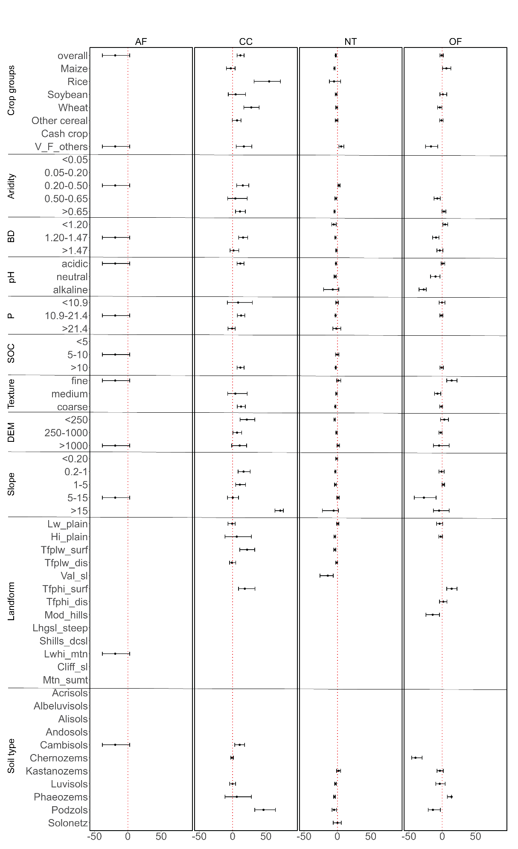

Supplementary material 3: Distribution of effect size for different management practices in the continental zone across different environmental moderators

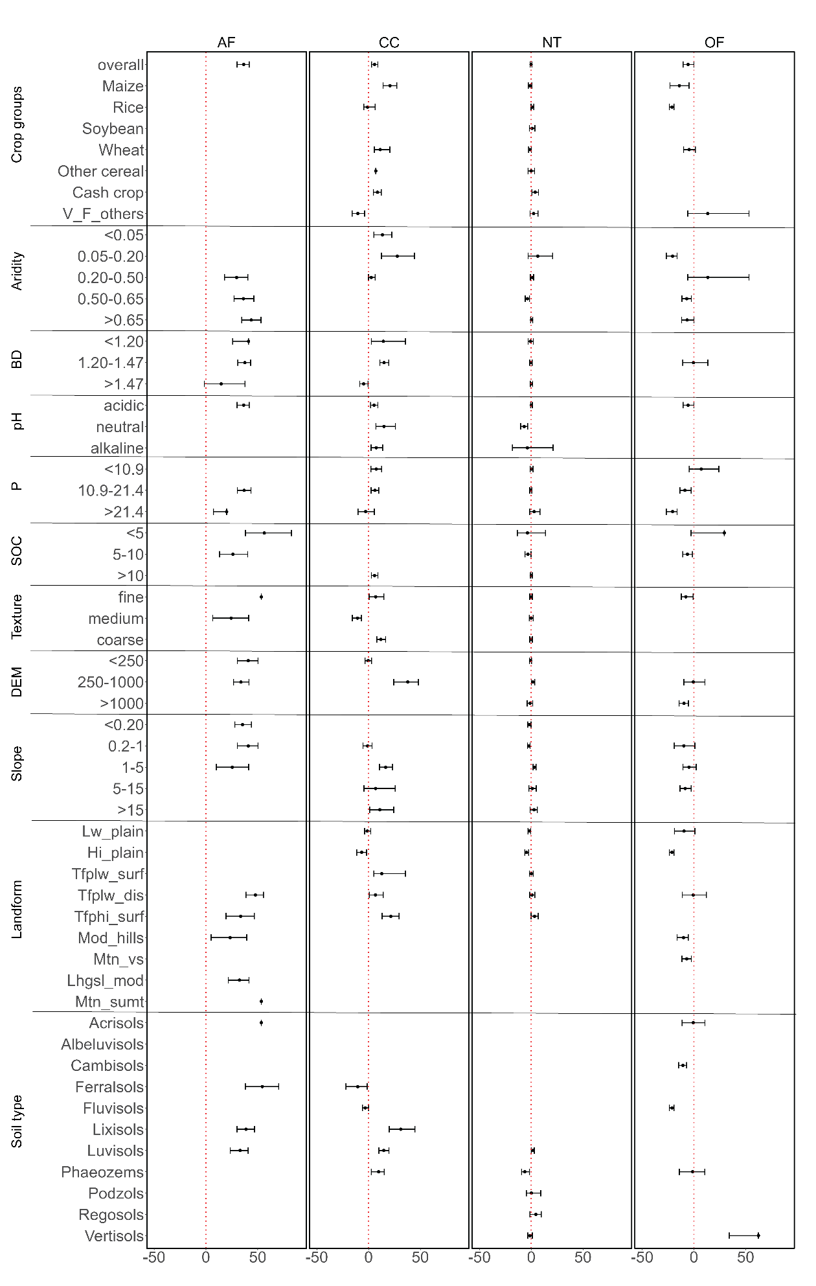

Supplementary material 4: Distribution of effect size for different management practices in the temperate zone across different environmental moderators

Supplementary material 5: Distribution of effect size for different management practices in the tropical zone across different environmental moderators